UNIT-IV
DESIGN ENGINEERING

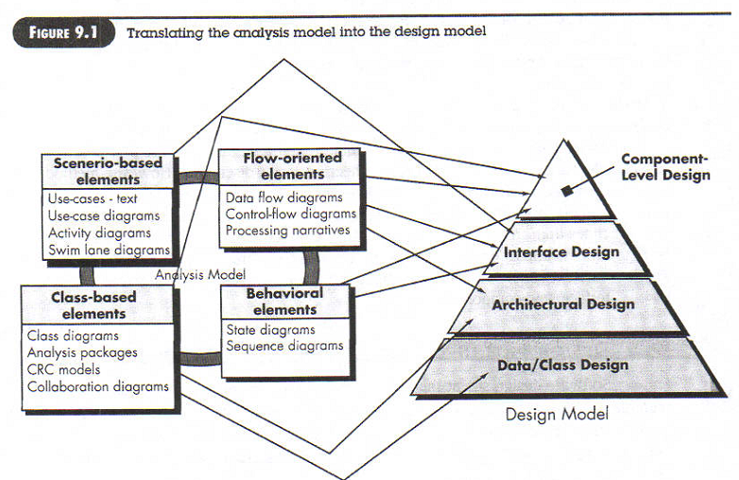
DESIGN PROCESS AND DESIGN QUALITY
- Encompasses the set of principles, concepts and practices that lead to the development of high quality system or product
- Design creates a representation or model of the software
- Design model provides details about S/W architecture, interfaces and components that are necessary to implement the system
- Quality is established during Design
- Design should exhibit firmness, commodity and design
- Design sits at the kernel of S/W Engineering
- Design sets the stage for construction
McGlaughin suggests three characteristics for the evaluation of a good design
- The design must implement all of the explicit requirements contained in the analysis model, and it must accommodate all of the implicit requirements desired by the customer.
- The design must be a readable, understandable guide for those who generate code and for those who test and subsequently support the software.
- The design should provide a complete picture of the software.
Quality Guidelines(What are the Characteristics of a good design?)
In order to evaluate the quality of a design representation, we must establish technical criteria for good design.
- A design should exhibit an architecture that (1) has been created using recognizable architectural styles or patterns, (2) is composed of components that exhibit good design characteristics and (3) can be implemented in an evolutionary fashion
- A design should be modular; that is, the software should be logically partitioned into elements or subsystems
- A design should contain distinct representations of data, architecture, interfaces, and components.
- A design should lead to data structures that are appropriate for the classes to be implemented and are drawn from recognizable data patterns.
- A design should lead to components that exhibit independent functional characteristics.
- A design should lead to interfaces that reduce the complexity of connections between components and with the external environment.
- A design should be derived using a repeatable method that is driven by information obtained during software requirements analysis.
- A design should be represented using a notation that effectively communicates its meaning.
Quality Attributes
Hewlett-Packard developed a set of software quality attributes that has been given the acronym FURPS-functionality, usability, reliability, performance and supportability.
Functionality: It is assessed by evaluating the capabilities of the program generality of the functions that are delivered, and the security of the overall system.
Usability : Assessed by considering human factors, consistency &aesthetics(appearance).
Reliability: Evaluated by frequency &severity of errors,MeanTimeToFailure& ability to recover from failure.
Performance: Measured by processing speed,response time,resource consumption,throughput&efficiency
Supportability:Combines ability to extend the program,adaptability&the ease with which the system can be installed.
Design Concepts:

1. Abstractions
2. Architecture
3. Patterns
4. Modularity
5. Information Hiding
6. Functional Independence
7. Refinement
8. Re-factoring
9. Design Classes
Abstraction:
- Many levels of abstraction
- Highest level of abstraction : Solution is slated in broad terms using the language of the problem environment
- Lower levels of abstraction : More detailed description of the solution is provided
- Procedural abstraction: :Refers to a sequence of instructions that has a specific and limited function.Ex The word open of a door which implies a long sequence of procedural steps (e.g., walk to the door, grasp the knob, pull the door& step away from moving door etc)
- Data abstraction: Named collection of data that describe a data object (Ex: door would encompass a set of attributes like door type,weight,dimensions etc.

Architecture:
- Architecture is the structure or organization of program components, the manner in which these components interact, the structure of the data that are used by components.
- Architectural design can be represented using one or more of a no of different models. Structural Models: An organised collection of program components
Framework Models: Identifies repeatable architectural design frameworks that are encountered in similar types of applications.
Dynamic Models : Represents the behavioral aspects indicating changes as a function of external events
Process Models:Focus on the design of the business or technical process
Functional Models:Used to represent functional hierarchy of a system.
Patterns
Design pattern describes design structure that solves a particular problem.
Provides a description to enables a designer to determine the followings :
(a). Whether the pattern is applicable to the current work
(b). Whether the pattern can be reused
(c). Whether the pattern can serve as a guide for developing a similar but functionally or
structurally different pattern
Modularity
- Divides software into separately named and addressable components, sometimes called modules
- Consider two problems p1& p2 if complexity of p1 is greater than complexity of p2 then the effort required to solve p1 is greater than p2.
- Based on Divide and Conquer strategy : it is easier to solve a complex problem when broken into sub-modules
- As the no of modules increases cost/module decreses
- As the no of modules increases cost to integrate increases
- Because of modularity testing and debugging can be done more efieciently.

Information Hiding
- Information contained within a module is inaccessible to other modules who do not need such information
- Achieved by defining a set of Independent modules that communicate with one another only that information necessary to achieve S/W function
- Provides the greatest benefits when modifications are required during testing and later
- Errors introduced during modification are less likely to propagate to other location within the S/W
Functional Independence
- A direct outgrowth of Modularity. abstraction and information hiding.
- Design a software so that each module addresses a specific subfunction of requirements & has a simple interface when viewed from other parts of program structure.
- Functional Independence is assessed using two conditions
Cohesion: Relative functional strength of a module.
Coupling: Indication of relative interdependence among modules.
Refinement
- Process of elaboration from high level abstraction to the lowest level abstraction
- High level abstraction begins with a statement of functions
- Refinement causes the designer to elaborate providing more and more details at successive level of abstractions
- Abstraction and refinement are complementary concepts.

Refactoring
- Refactoring is a reorganization technique that simplifies design (or code) of a component without changing its function or behavior.
- Fowler defined that refactoring is a process of changing software system in such a way that it does not alter external behavior of code yet improves its internal structure.
- When software is refactored existing design is examined for redundancy, unused design elements, inefficient algorithms, inappropriate data structures or any other design failures.
Design Models
DATA DESIGN ELEMENTS:
Data design creates a model of data and/or information that is represented at a high level of abstraction.
- The structure of data has always been an important part of software design
- At the architectural (application) level, data design focuses on translation of data model into a database.
- At the program component level, data design focuses on data structures that are required to implement the local data objects
- At the business level ,the collection of information stored in disparate databases and recognized into a “data warehouse” which enables data mining.
Architectural Design Elements
- The architectural design for software is equivalent to floor plan of a house. Floor plan gives us an overall view of house.
- Architectural design elements give us an overall view of software.
- The architectural model is derived form 3 sources:
- Information about application domain for software to be built.
- Specific analysis model elements such as Data Flow Diagram or analysis classes.
- Availability of architectural styles and patterns.
Interface Design Elements
- The interface design for software is equivalent to set of detailed drawings for doors, windows and external utilities of a house..They tell us how information flow into and out of house and within rooms that are part of house.
- The interface design elements for software tell how information flows into and out of the system and how it is communicated among components defined as part of architecture.
- There are three important elements of interface design
- The user interface
- Extrernal interfaces to other systems,devices,networks,or other consumers of information
- Internal interfaces between design componens
- The design of UI incorporates
  - Aesthetic elements(layout,color,graphics,interaction mechanisms)
  - Erogonmic elements ( information layout and placement,metaphors)
  - Technical elements (UI patterns,reusable components)
- The design of external interfaces requires definitive information about the entity to which information is sent or received.
- The design of internal interfaces is closely aligned with component-level design
- UML defines an interface in the following manner: An interface is a specifier for the externally visible [public] operations of a class.
  - For ex Safe Home Security function makes use of control panel that allows homeowner to control certain aspects of security function. Control panel functions may be implemented via a wireless PDA or mobile phone.

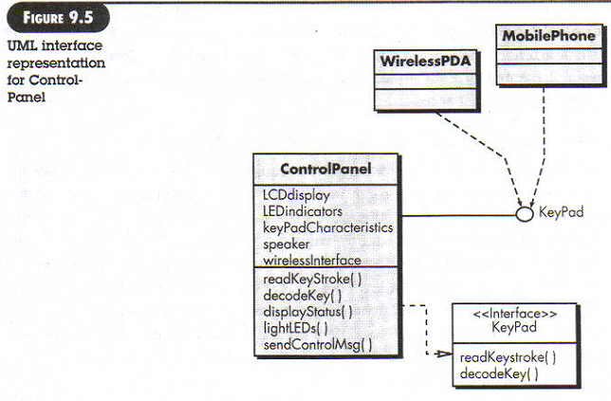
- The Control Panel class of fig 9.5 provides behavior associated with a keypad and therefore it must implement operations read keystroke() and decode key().If these operations are to be provided to other classes it is useful to define an interface as shown in fig

- The interface named keypad is shown as an <<interface>> stereotype or a small, labeled circle connected to class with a line. The interface is defined with no attributes. But represent a set of operations necessary to achieve behavior of keypad.
- The dashed line with an open triangle at its end indicates that control panel class provides keypad operations as part of its behavior.In UML this is characterized as a realization.

Component-Level Design Elements:
- The component-level design for software is equivalent to set of detailed drawing s for each room in a house. These drawings depict wiring and plumbing within each room, location of switches, showers, drains etc.They also describe flooring to be used and every other detailed associated with a room.
- Component-level design for software fully describes the internal detail of each software component.
- To accomplish this, component-level design describes data structures for all local data objects and algorithmic detail for all processing that occur within a component and an interface that allows access to all component operations.
- In UML the diagrammatic form as shown in fig 9.6.The component, named sensor management is represented. A dashed arrow connects the component to a class named sensor. The sensor management component performs all functions associated with Safe home sensors.
- 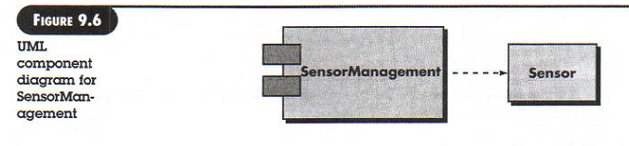 The design details can be modeled at different levels of abstraction. An activity diagram can be used to represent processing logic. Detailed procedural flow of a component can be represented using either pseudo-code or some diagrammatic form.
Deployment-Level Design Elements
- They indicate how software functionality and subsystems will be allocated within computing environment that will support the software.
- For Ex the elements of Safe home product are configured to operate with three primary computing environment.-A home-based PC, Safe home control panel and a server housed at CPI corp.
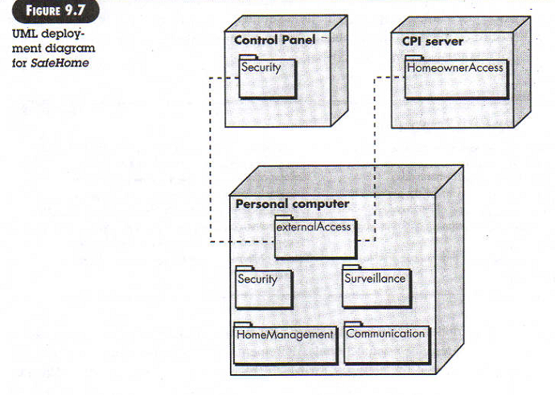
- In UML Deployment diagram is developed as shown in fig 9.7 The subsystems housed within each computing element are indicated
- The diagram shown in fig.9.7 is in descriptor form. This means deployment diagram shows computing environment but does not explicitly indicate configuration details. For ex PC could be a Macintosh, or a sun workstation or a linux.These details are provided when deployment diagram is revisited during later stages of design or as construction begins.

